

Advanced Service Assets

How to Use Data Abstraction Best Practices Manage Annotations v8.1.8
Data Virtualization Business Unit Advanced Services
May 2017

TABLE OF CONTENTS
INTRODUCTION 4
Purpose 4
Pre-Requisites 4
CONFIGURATION 5
How to Configure 5
Manage Annotation Script Configuration Summary 5
Best Practices Installation 5
Executing CIS Resource Annotations 6
Introduction 6
Instructions 6
ResourceAnnotation Spreadsheet Definition 7
Manage Annotation scripts method definitions 8
Detailed Definitions 8
Annotation Maintenance: Generate Annotations 8
1. generateResourceListToCSV 8
Annotation Maintenance: Update Annotations 8
2. updateAnnotations 8

Document Control
Version History
Version | Date | Author | Description
8.1.8 | 05/24/2017 | Mike Tinius | Updated for Best Practices v8.1.8 – added Manage Annotation scripts.
Related Documents
Document | Date | Author
How To Learn DVBU AS Best Practices | How To Use DVBU AS Best Practices.pdf | Mike Tinius
Data Virtualization Business Unit (DVBU) Products Referenced
DVBU Product Name | Version
Composite Information Server | 7.0
INTRODUCTION

Purpose
The purpose of Best Practices Manage Annotation Scripts is to provide a framework for performing mass-updates on resource annotations based on rows maintained in a spreadsheet or a database.
The Manage Annotation Scripts help the developer to maintain and execute annotation updates during deployment for the various layers. The proper place for annotations to be set (especially column annotations) is at the immediate layer below the published layer. According to the best practices this may be either the Application Layer Published or Application Layer Views. The reason for this is that CIS Business Directory reads annotations from the layer of views just below the published. In fact, there is no way to set COLUMN annotations on published resources. The red highlighted boxed indicate where annotations are set depending on which layer is directly published to the CIS Published Database Layer.
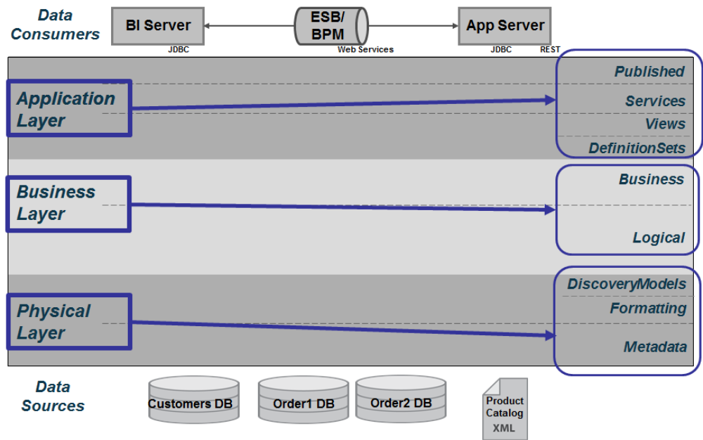
Figure one: Technical Data Abstraction Layers

Pre-Requisites
Follow the steps below to create a new project.
- LDAP groups have been brought into the target environment.
- /shared/ASAssets/Utilities have been installed and configured for 2017Q2.

CONFIGURATION

How to Configure
This section provides information on how to configure the Manage Annotation Scripts.

Manage Annotation Script Configuration Summary
- Copy annotaion spreadsheet to file system
- Modify datasource connections
- Reintrospect datasources
- Test datasources

Best Practices Installation
- Install Best Practices Spreadsheets
  - Follow the Data Abstraction Best Practices installation directions found in this document: “How To Use DVBU AS Best Practices.pdf”
- Copy annotaion spreadsheet to file system
  - This should have been done during installation of the Best Practices. Verify this.
- Modify the data source path or connection information:
  - EXCEL: modify the root path if needed.
    - CIS Location: [EXCEL] /shared/ASAssets/BestPractices_v81/ManageAnnotations/Metadata/ManageAnnotations_EXCEL
    - E.g. root path: C:/CiscoSystems/BestPractices/Annotations
- Reintrospect the “ManageAnnotations_EXCEL” data source
- Test the data source
  - Show Contents for the “ResourceAnnotations” worksheet to insure that data is being retrieved.
- Generate the Resource Annotation spreadsheet using the script /shared/ASAssets/BestPractices_v81/ManageAnnotations/generateResourceListToCSV
- Modify the annotations as needed
- Place the values back into the original spreadsheet for use during “updateAnnotations”.

Executing CIS Resource Annotations

Introduction
This section provides guidance on how to manage the process for generating and updating CIS resource annotations.

Instructions
- The basic flow looks like this
  - Generate the Resource Annotation spreadsheet using the script /shared/ASAssets/BestPractices_v81/ManageAnnotations/generateResourceListToCSV
    - Resources get generated onto the CIS server. You will need a download user folder and the ability to FTP the file to your local machine.
    - Generate Resource Annotation List to CSV
      - Sheet: ResourceAnnotations
      - Script: generateResourceListToCSV
        - startingPath: /shared/lab00/Application/Views/ds_orders1
        - csvFilePath: C:\BestPractices\Annotations\note.csv
  - Modify the annotations as needed
    - Convert the .csv to .xlsx as it makes it easier to edit
  - Place the values back into the original spreadsheet for use during “updateAnnotations”.
    - Either rename the file you downloaded or copy the values back to the original ResourceAnnotations.xlsx spreadsheet.
  - Upload the file back to the CIS server to replace the existing one.
  - Test the data source
    - Show Contents for the “ResourceAnnotations” worksheet to insure that data is being retrieved.
  - Update Resource Annotations
    - Sheet: ResourceAnnotations
    - Script: updateAnnotations
      - performUpdate: 0 or 1.
      - The next parameter “inSqlStatement” provides the user with a way to inject there own datasoure rather than using the default
      - inSqlStatement: select PhysicalName, PhysicalType, ResourcePath, ResourceAnnotation from /shared/ASAssets/BestPractices_v81/ManageAnnotations/Formatting/ResourceAnnotations

ResourceAnnotation Spreadsheet Definition
- The basic flow looks like this
There are several columns that get generated that provide good informational value. However, there are only four columns that matter when performing the “updateAnnotations” and those are as follows:
PhysicalName, PhysicalType, ResourcePath, ResourceAnnotation

This chart describes the columns in the ResourceAnnotations spreadsheet:

Column Name | Description
DataSourceName | The data source name that the ResourcePath maps to if applicable.
DataSourceType | The data source type that the ResourcePath maps to if applicable.
DataSourceHostname | The data source hostname that the ResourcePath maps to if applicable.
PhysicalName | The name of the CIS resource.
PhysicalType | The type of the CIS resource. E.g. [TABLE, COLUMN]
ResourcePath | The full path of the CIS resource. Paths are not double-quoted if they contain spaces or special characters.
ResourceAnnotation | The mult-line annotation of the CIS resource.
ColumnDependencies | The column dependency lineage.

Manage Annotation scripts method definitions

Detailed Definitions
Detailed documentation on the inputs and outputs can be found in the header and annotation section of each procedure.

Annotation Maintenance: Generate Annotations
- generateResourceListToCSV – This procedure is used to generate the table and column annotations to a CSV file on the CIS server. The user is responsible for downloading the file to their local workstation to work on the annotation list.
  - Location: /shared/ASAssets/BestPractices_v81/ManageAnnotations/generateResourceListToCSV
Direction | Parameter Name | Parameter Type
IN | startingPath – path to folder that is one level below the published data service folder. Note: the startingPath may be a parent path as the procedure. This procedure recursively drills into child folder paths to find views. The reason for one level below the published is because this is where Business Directory gets the column annotations. | LONGVARCHAR
IN | csvFilePath – The output file path on the CIS server. The user is responsible for downloading the file to their workstation for editing. | LONGVARCHAR

Annotation Maintenance: Update Annotations
- updateAnnotations – This script is used to update resource annotations. The main objective is to update the resources and columns at the level directly below the published datasource layer in CIS. This is the layer in which table columns may be updated. This is the layer in which Business Directory will read in the column metadata.
  - RULES:
    - If the annotation in the spreadsheet is blank with no spaces, it is considered a null indicating take no action. The update of the annotation for that resource is not performed.
    - If the annotation in the spreadsheet contains 1 or more blanks, it is considered a modification and the update of the annotation will be performed and will blank out any existing annotation.
    - If the annotation in the spreadsheet contains non-space characters, it is considered a modification and the update of the annotation will be performed modifying the existing annotation.
    - If the annotation in the spreadsheet contains multiple lines then all lines will be taken as is and and the resource annotation will retain those lines.
    - If the PhysicalType = 'TABLE' then the table annotation will be modified otherwise it is assumed to be a COLUMN annotation.
  - Location: /shared/ASAssets/BestPractices_v81/ManageAnnotations/updateAnnotations
Direction | Parameter Name | Parameter Type
IN | performUpdate – 0=do not perform update, 1=perform update environments. Basically it is used for testing purposes and developing new functionality. | INTEGER
IN | inSqlStatement – The table is provided by the user but the columns must match exactly as shown.  This strategy allows the user to store there annotations in their own datasource [excel or database] in order to manage their annotations.  Default Select if inSqlStatement is left null:  select PhysicalName, PhysicalType, ResourcePath, ResourceAnnotation from /shared/ASAssets/BestPractices_v81/ManageAnnotations/Formatting/ResourceAnnotations | LONGVARCHAR
OUT | rowsProcessed – number of rows processed from the spreadsheet | INTEGER


Printed in USA CXX-XXXXXX-XX 10/11

